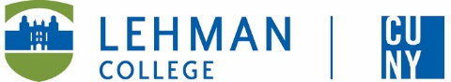

Leonard Lief Library
Latin American and Latino Studies
present
A Reading and Discussion

Dictatorship Across Borders
Brazil, Chile, and the South American Cold War
by Mila Burns
A trailblazing analysis of Brazil’s influence on the 1973 Chilean coup d'état - this book offers a groundbreaking perspective on the 1973 Chilean coup. It highlights Brazil’s pivotal role in shaping the political landscape of South America during the Cold War. Shifting the focus from the United States to interregional dynamics - Mila Burns argues that Brazil was instrumental in the overthrow of Salvador Allende and establishment of Augusto Pinochet’s dictatorship.
Drawing on original documents, interviews, and newly accessible archives - particularly from the Brazilian Truth Commission - Burns reveals Brazil’s covert involvement in the coup, providing weapons, intelligence, and even torturers to anti-Allende forces.
She also explores resistance networks formed by Brazilian exiles in Chile. Burns’ impeccable research - combining history, anthropology, and political science - makes Dictatorship Across Borders a vital addition to Cold War studies, reshaping how we understand power and resistance in South America.
Mila Burns is Associate Professor of Latin American and Latino Studies at Lehman College.
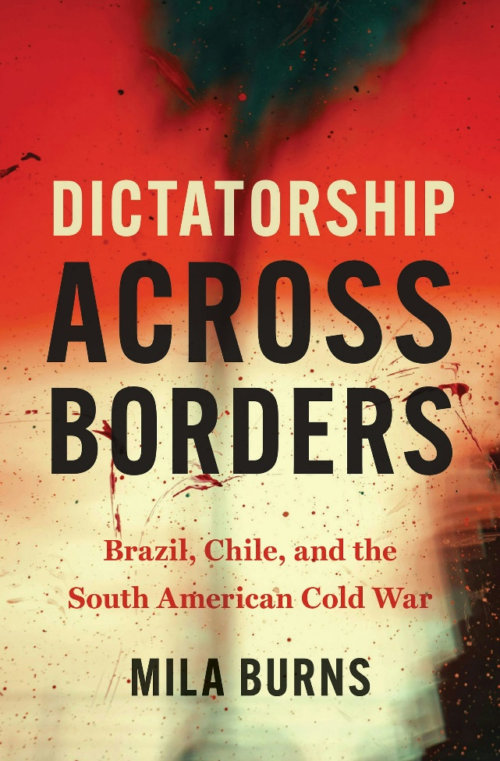

Wednesday, September 17, 2025
12:00 - 1:00 PM
RSVP by September 16th: https://libcal.lehman.edu/event/15269915
Location: Library - Treehouse Conference Room 317
*Registration is required*
Information: Bernice.Suphal@lehman.cuny.edu

