How to Cancel a Requisition

BUSINESS OBJECTIVE: If goods or services are no longer required and a PO has not been created against the request, there may be times when a requisition will need to be canceled. When a requisition is canceled, the pre- encumbrance is released once the canceled requisition is budget checked.

STEP#1: Navigate to eProcurement>Manage Requisitions and search for the requisition. Click on the and select ‘Cancel Requisition’ then click on the button.
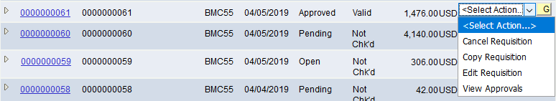

STEP#2: Click on the ‘Cancel Requisition’ button.
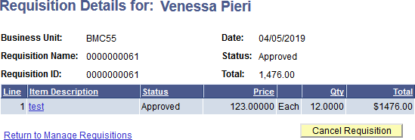
Once the requisition is canceled, the status of the requisition changes to ‘Canceled’.

STEP#3: Requesters need to do a budget check to ensure pre-encumbrance funds return back to their budget. Click on the and select ‘Check Budget’ then click on the button.
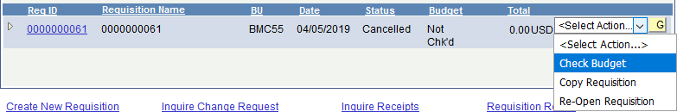
Once the requisition has been budget checked, the budget status of the requisition changes to ‘Valid’. This completes the cancel process and ensures funds are returned to the budget for the department.

your Accounts Payable Office.

