Creating Requisitions

BUSINESS OBJECTIVE: CUNY acquires goods and services through a competitive bidding process managed by the Purchasing department. Departments are required to create a requisition stating their business needs. It is strongly recommended that Requesters run the Budget Overview query in CUNYfirst to confirm the general availability of funds prior to creating a requisition. If sufficient funds do not exist, requisitions will fail budget checking process and will not route to the Purchasing department. Requesters must contact their Budget Office to correct budget issues.

From the Enterprise Menu, Select the Financial Supply Chain link.
Navigate to: eProcurement > Create Requisition. If prompted, enter your Business Unit, Requester (when applicable) and click on Ok.

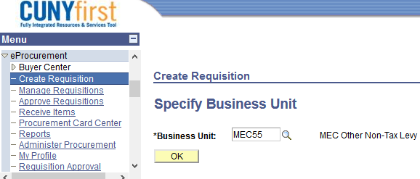
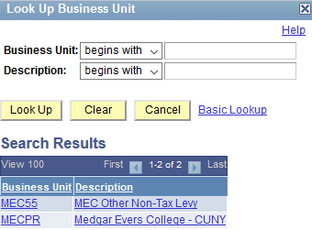

There are three stages in the creation of a requisition.
| 1. Define Requisition | 2. Add Items and Services | 3. Reviewing and Submitting |
1. Define Requisition

STEP#1: It is good practice to name your requisition, see example below and click on Continue.
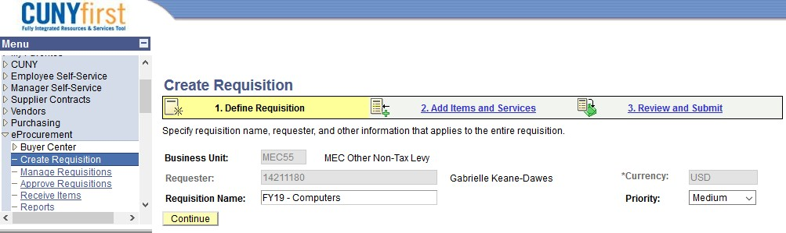

2. Add Items and Services
STEP#1: Always click on Special Request tab, then Special Item.
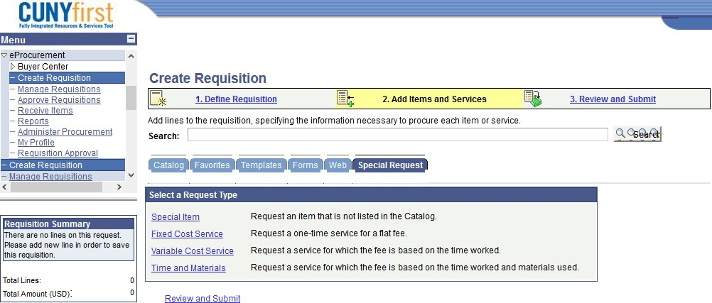

STEP#2: Enter all required information including Item Description, Price, Quantity, Category Code and Unit of Measure. Vendor ID is not required.
Here are the most commonly used category codes:

Code | Descr | Expense  Account | Budgetary  Account | Inspection  Required
4412000000 | Office supplies | 51001 | 80120 | N
6014000000 | Toys & games | 51105 | 80120 | N
4321160002 | Computer  Accessories<$5K | 53912 | 80123 | Y
4321000102 | Computer hardware  <$5K | 53912 | 80123 | Y
For complete list of category codes, run query BUD_CATEGORY_CODES_OTPS_NTL

STEP#3: Enter Click on Add Item.
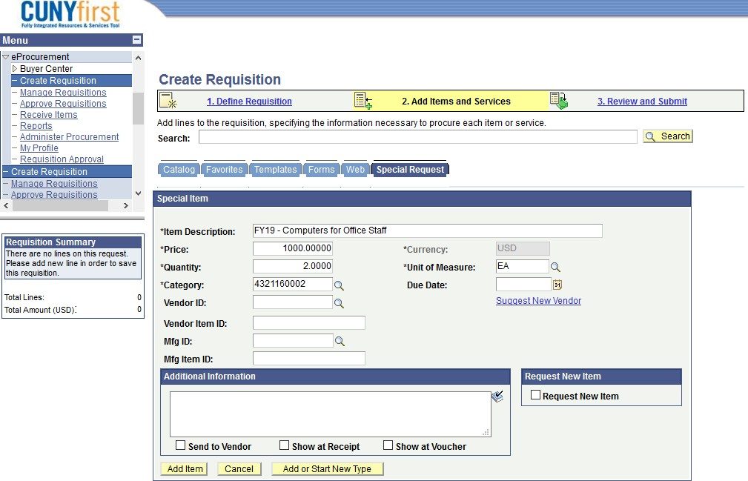

STEP#4: The item will display in the Requisition Summary box to your left. The system is ready to enter any additional requisition lines details as needed. For this example, we will review the single item and submit the requisition for approval and budget check. Click on Review and Submit.

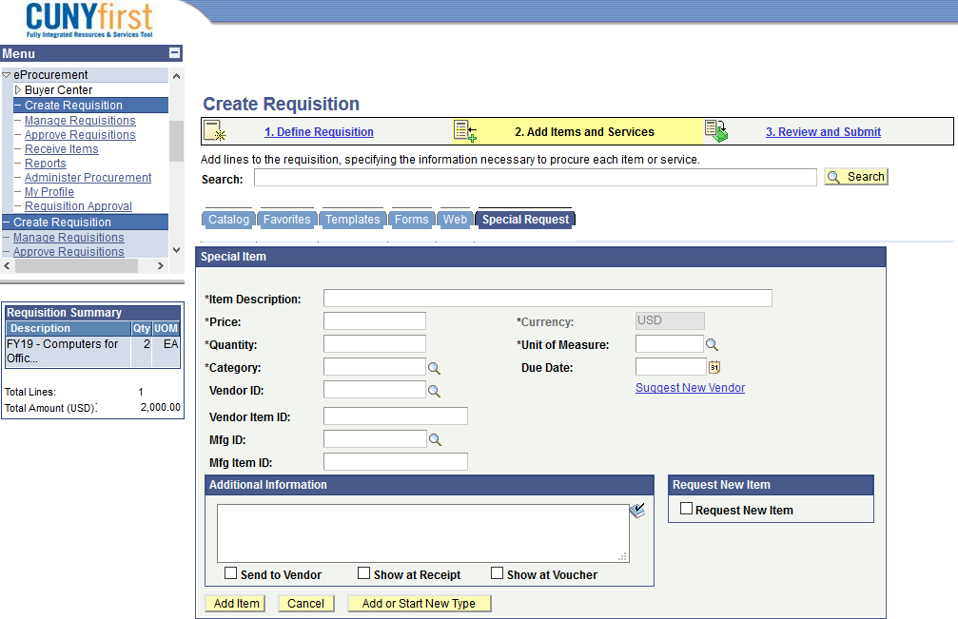
STEP#5: Click on the triangle to the left of the Line Description to see more details
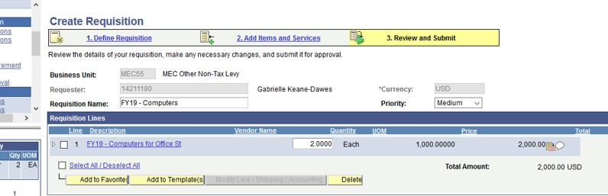

3. Review and Submit

STEP#1: All requesters have a set of default chartfields (CUNYfirst codes that identify the transactions in the system) when they were initially setup in CUNYfirst. Example of chartfields are GL Unit, Account, Dept.#, Major Purpose Code, Budget Date and others. Default chartfields can be reviewed and changed for each line in the requisition. You can see all of them by clicking ‘Chartfield1’, ‘Chartfield2’, ‘Chartfield3’ and ‘Details’ tabs.

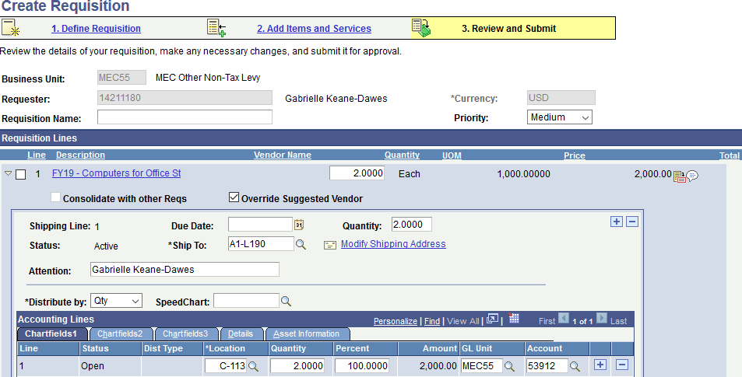
STEP#2: Line items on a requisition can be created as “quantity based” for goods and materials and amount only
for services or blanket purchase orders. This requisition is quantity based requisition.
By clicking on Chartfields2 and Chartfields3, you can review/change the chartfields associated with this requisition. Each requestor has a set of default chartfields that will automatically populate a requisition. These chartfields can be change during the creation of the requisition.
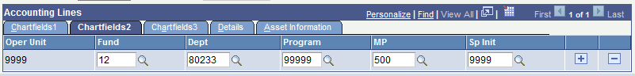

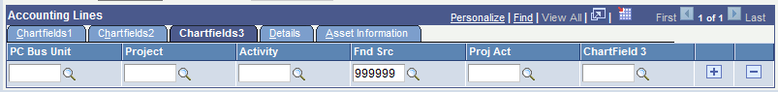

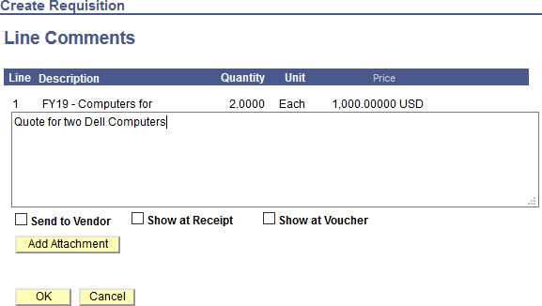
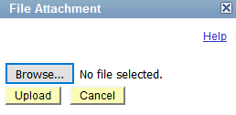
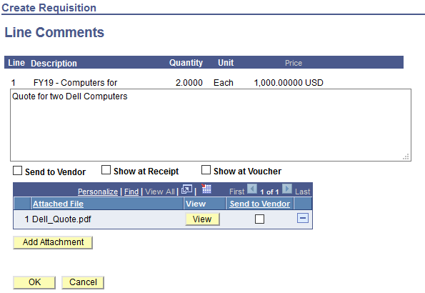
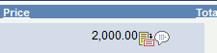
STEP#3: Requesters are required to add supporting information as an attachment. At minimum the following documents are required:

ut is now filled. Indicating that ents and/or attachments exit.

Callo comm
- Needs justification (What and why are you requesting this goods/services)
- Any vendor budgetary quote (details of good/services to be acquired and cost)
- Any additional supporting documentation.

Purchasing agents will use the attached support to document their due diligence and compliance process. Click on the callout icon to add supporting documentation.

STEP#4: Click Add Attachment icon to add attachment(s), browse to select the file(s). Use short and concise file naming convention. For example: Needs Justification; Budgetary Quote; etc. click Upload and finally OK.

STEP#5: Once the requisition is ready to be saved, click on Save & preview approvals. This will save the requisition by assigning a requisition ID and will illustrate the approval routing the requisition will follow.
STEP#6: Workflow routing will display. Click Submit to initialize the approval process.

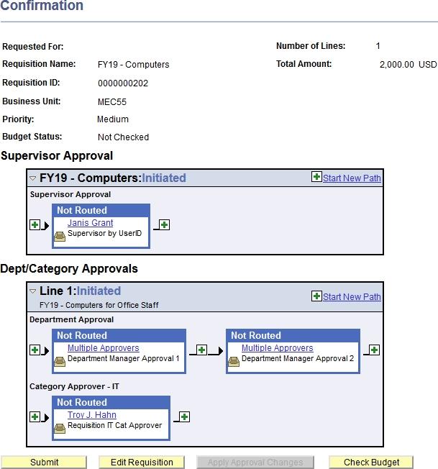
NOTE: Approvers will receive an email notification that a requisition is awaiting their approval. Once the requisition has been fully approved by all parties (supervisor, department approvers and in some cases category approvers), the requisition will then be available for the budget check process. Budget check process runs automatically at the top of every hour

