Approving Requisitions

BUSINESS OBJECTIVE: All requisition approvers (supervisors, department approvers, category approvers) will receive an email notification with a link to approve pending requisitions. However, approvers are encouraged to use the Approve Requisitions search page to search for pending requisitions. Category approvals are required for Information Technology, furniture, hazardous materials and outside legal counsel.
This page also offers the ability to search for requisitions that have been approved, denied, pending or pushed back. Approvers need to carefully review supporting information including requisition chartfields plus supporting documentation prior to approval.
STEP#1: Navigate to eProcurement>Approve Requisitions

Enter as much information to locate the requisition to be approved. For example, enter ‘date from’ and ‘date to’ and keep default Status; Pending. Click Search.
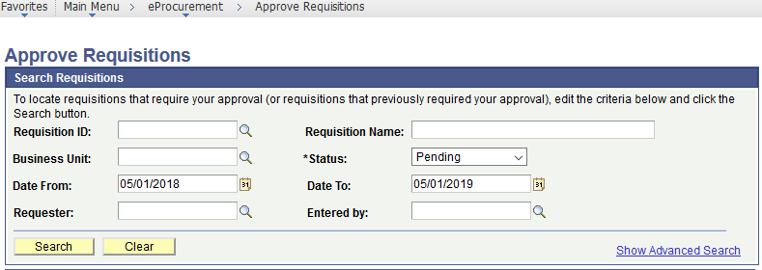

STEP#2: Summary requisition results are displayed. Click on Req ID to review requisition details prior to approval.

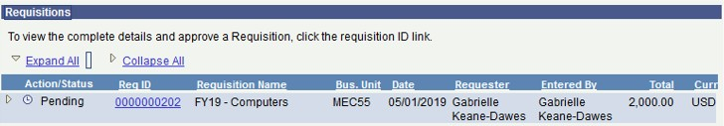

STEP#3: To review the requisition line detail, place a check mark on the requisition line to be reviewed and click on

View Line Details icon. Requisition Details appear.

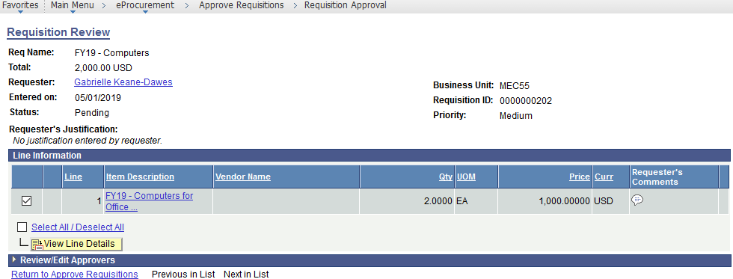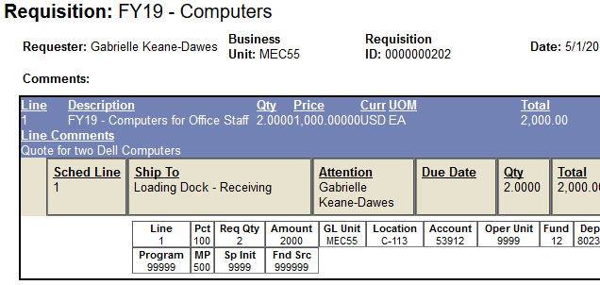

STEP#4: Once all requisition details have been reviewed and supporting documents verified, the requisition is ready to be approved. Return to the Requisition Approval Page and Click on Approve

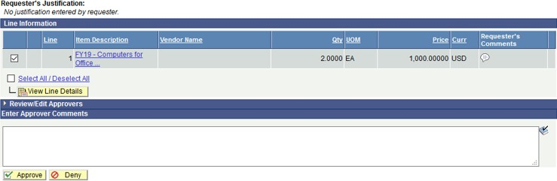

Did you review the attached supporting documentation?

STEP#5: Image below illustrates a fully approved requisition:

